**Uninformed Search**

Problem Solving as Search

• Search is needed to solve many real-world problem

8-puzzle problem Planning Go

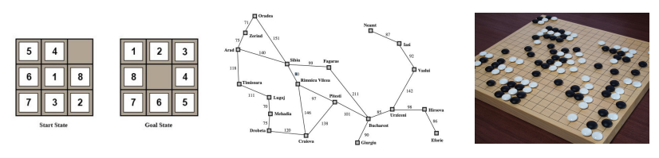

• Search is a central topic in AI

— Automated reasoning

— More recently: Given that almost all AI formalisms (planning, learning, etc.) are **NP-complete** or worse, some form of search is generally unavoidable (no “smarter” algorithm available).

Define a Search Problem

• A **search problem** consists of:

• **State space**: 

• A **successor function**: (action + cost)

• A **start state** and a **goal test**:

• A **path** is any sequence of states connected by a sequence of actions.

• **Path cost** – function that assigns a cost to a path; relevant if more than one path leads to the goal, and we want the shortest path.

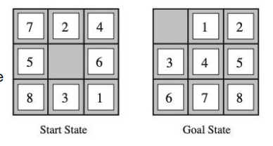• A **solution** is a sequence of actions (a plan) which transforms the **start state** to a **goal state**.

Example: The 8-Puzzle

• **State space**: • The location of each tile

• **Initial state**: • Any state can be the inital state

• **Goal test**: • Whether the state matches the goal state

• **Successor function**: • The movement of the blank space (Left, Right, Up or Down)

• **Path cost**: • Each step costs

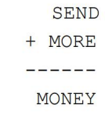Example: Cryptarithmetic

• Find **substitution of digits** **for letters** such that the resulting sum is arithmetically correct.

• Each letter must stand for a different digit.

• **State space**: an 8-tuple indicating a (partial) assignment of digits to letters.

• **Goal test**: all letters have been assigned digits and sum is correct

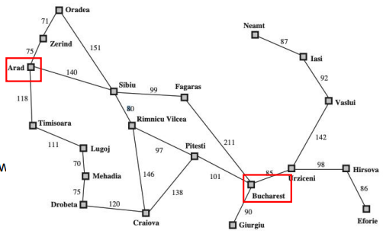• **Successo**r function: represents the act of assigning digits to letters

• **Path cost**: all solutions are equally valid; step cost = 0

Example: Traveling in Romania

**• State space**: • Cities

• **Initial state**: • Arad

• **Goal test**: • Is state == Bucharest

• **Successor function**: • Roads: go to adjacent cities with cost = distance

• **Path cost**: • The cost of a path

Solving a Search Problem: State Space Search

• **Input:** • Initial state • Goal test • Successor function • Path cost function

• **Output:** path from initial state to goal. Solution quality is measured by the path cost function

• Expanding: apply each legal action to the current state

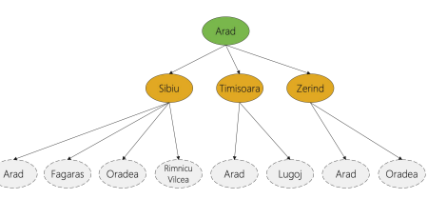• The leaf nodes available for expansion is called the frontier

Search procedure defines a search **tree**

**root node** — initial state

**Children of a node** — successor states

**Leaves of tree (frontier)** — states not yet expanded

**Search strategy** — algorithm for deciding which leaf node to expand next

Node Data Structure

• Node data structure is used to **keep track of** the search

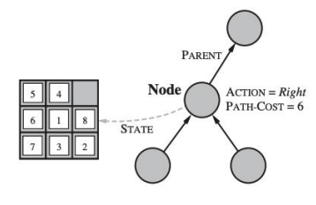• Nodes vs. States

• A node is a **bookkeeping data structure** used to represent the search tree

• A state corresponds to a **configuration** of the world

Evaluating a Search Strategy

• Completeness: is the strategy guaranteed to find a solution when there is one?

• Time complexity: how long does it take to find a solution?

• Space complexity: how much memory does it need?

• Optimality: does the strategy find the highest-quality solution when there are several different solutions?

Generic Tree-Search Algorithm

Add **initial state** to the **frontier**

Loop

**node** = remove-frontier( ) -- and save in order to return as part of path to **goal**

if goal-test(**node**) = true return path to goal

S = successors(**node**)

Add **S** to **frontier**

until **frontie**r is empty

return **failure**

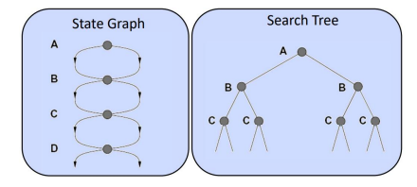Tree Search vs. Graph Search

• **Tree search** allows a state to be expanded more than once

• Failure to detect repeated states can cause more work

• Advantage: memory-efficient

Graph Search

•Idea: never expand a state twice

• How to implement:

• Tree search + set of expanded states (“closed set”)

• Expand the search tree node-by-node, but…

• Before expanding a node, check to make sure its state has never been expanded before

• If not new, skip it, if new add to closed set

Uninformed Search: BFS

• Use the **first-in, first out or FIFO** queue to store the frontier

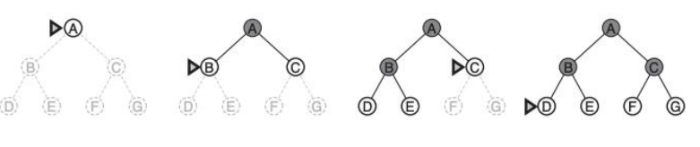• Consider paths of length 1, then of length 2, then of length 3, then of length 4, .

Time and Memory Requirements for BFS

• Let **b = branching factor** -> maximum number of successors of any node

• **d = solution depth** -> the shallowest goal node

• Then the maximum number of nodes generated is: b + b2+ ... + bd = O(bd)

• For graph search, O(bd-1) in the closed set and O(bd) in the frontier

• **branching factor = 10** • 1 million nodes / second • each node requires 1000 bytes of storage

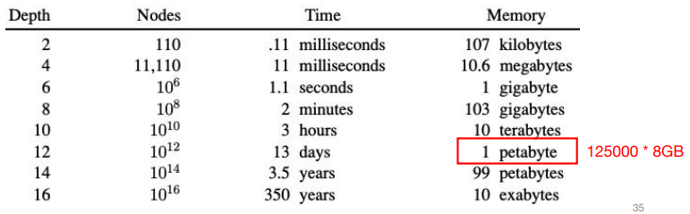

Uniform-Cost Search

• **Use BFS**, but always expand **the lowest-cost node** on the frontier as measured by path cost g(n)

• **g(Successor(n)) > g(n)** is a **necessary condition** for completeness and a **sufficient condition** for optimality

Uninformed search: DFS

• Use the last-in, first out or LIFO queue to store the frontier

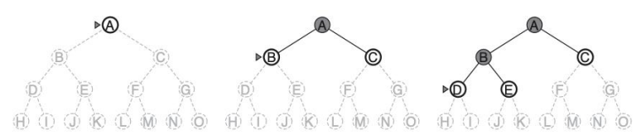

Time and Memory Requirements for DFS

• Let **b = branching factor** -> maximum number of successors of any node

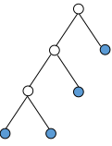• **m = maximum depth of any node**

• Time: for tree search, then the maximum number of nodes generated is: **O(bm)**

• Space: for tree search, only need to store **O(bm)** nodes

• at depth l < d we have b-1 nodes

• at depth d we have b nodes

• total = (m-1)*(b-1) + b = O(bm)

DFS vs. BFS

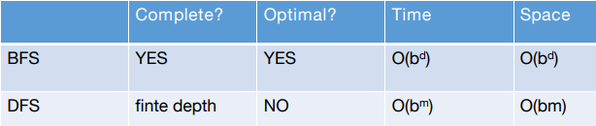

**d**: depth of the shallowest solution **m**: maximum depth

• Takeaways:

• If the solution is not far from the root: BFS might be faster

• If the search tree is very deep: DFS may never find solution

• If the search tree is wide: BFS might take too much memory

• If d is known: DFS is preferred

• If optimal solution is needed: BFS is preferred

Iterative Deepening [Korf 1985]

• Problem of DFS: cannot avoid infinite loops

• Idea: Use an artificial depth cutoff, **c**. If search to depth **c** succeeds, we are done. if not, increase **c** by 1 and start over. Each iteration searches using DFS. Combine the benefit of the DFS and BFS

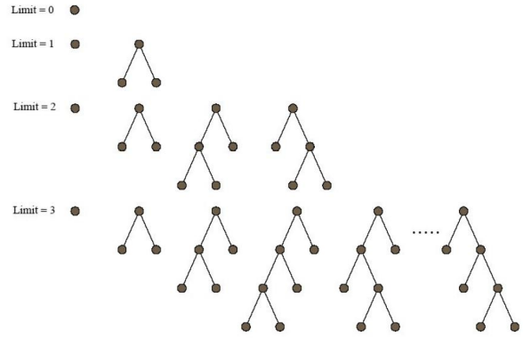

Iterative Deepening

• Space requirements: same as DFS.

• Time requirements: would seem very expensive! But not much different from single BFS or DFS to depth d

• Reason: **Almost all work is in the final couple of layers**. E.g., binary tree: 1/2 of the nodes are in the bottom layer. With b = 10, 9/10th of the nodes in the final layer!

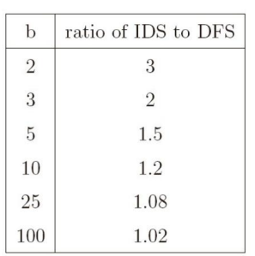• So, repeated runs are on much smaller trees (i.e., expoentially smaller)

Examples: b = 10, d = 5, the number of nodes generated in a BFS:

b + b2 + ... + bd = 10 + 100 + 1,000 + 10,000 + 100,000 = 111,110

For **IDS**: (d)b + (d-1)b2 + ... + (1)bd = 50 + 400 + 3,000 + 20,000 + 100,000 = 123,450

Cost of repeating the work at shallow depths is not prohibitive

Cost of Iterative Deepening

• Space: O(bd) as in DFS, time: O(bd)

• Asymptotic ratio of the number of nodes generated by BFS and IDS: • (b+1)/(b-1)

Bidirectional Search

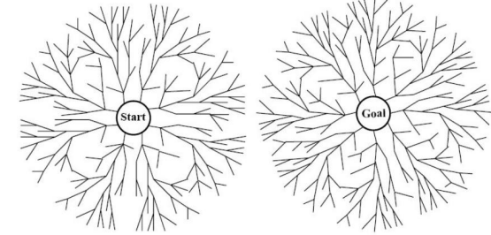

• When is bidirectional search applicable?

• Generate predecessors is easy • Goal state is clearly specified. (“no queen attacks another queen”)

• **Search forward from the start** state and **backward from the goal** state simultaneously and **stop when the two searches meet the middle**.

• If **branching factor = b** from both directions, and solution exists at **depth d**,

then need only O(2bd/2) = O(bd/2) steps.

• Example: b = 10, d = 6 then BFS needs 1,111,110 nodes and bidirectional search needs only 2,220.

Limitations

• What are the problems of all the methods? **Slow**!

• The search is blind in the sense that the information of the goal state is not used

• Informed search: • with the guidance of the goal state.

**Informed Search**

Define a Search Problem

• A **search problem** consists of:

• **State space**: 

• A **successor function**: (action + cost)

• A **start state** and a **goal test**:

**b: branching factor** **d: depth of the shallowest solution** **m: maximum depth**

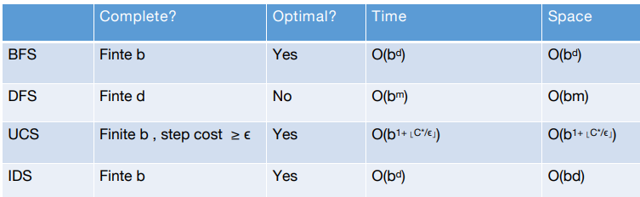

Informed Methods: Heuristic Search

• Informed methods use problem-specific knowledge

**• The location of the goal**

• Humans rely on informed search!

• We want to have some **estimate** of the distance from **the states** **in the frontier** to **the goal state**.

• Why estimate? Because the states we can reach are based on the actions we can take.

• We use an **evaluation** function f(n) as our **estimate**

• Best-first search:

**• Nodes are selected for expansion** based on the evaluation function, f(n).

• Expand the node with the **lowest** evaluation

• The evaluation function can be complex: f(n) = f1 (n) + f2 (n) + …

Greedy Best-First Search

•One natural component of f(n):

• Heuristic function:

• h(n) = **estimated cost** of the **cheapest** path from the state at **node n** to a **goal state**

Heuristic search is an attempt to search the most promising paths first.

• Greedy Best-First Search

• Expands the node that is “closest” to the goal as measured by h(n)

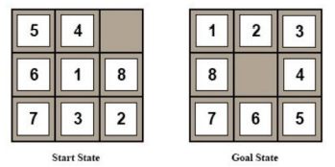• A common case:

• Best-first takes you straight to the (wrong) goal

• Worst-case: like a badly guided DFS.

Example: 8-puzzle problem

• Design of heuristic function is important

• One possible heuristic function: • The number of tiles misplaced

Example: Find a Path from Arad to Bucharest

• One possible heuristic function:

• the straight-line distance to Bucharest

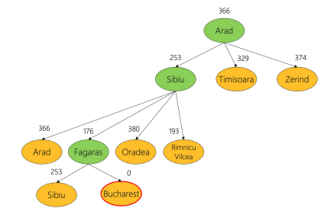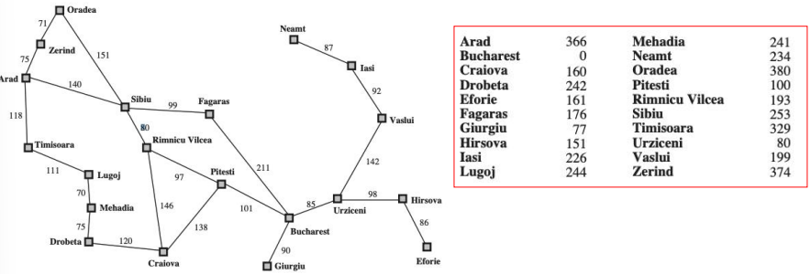

Example: Find a Path from Arad to Bucharest

• One possible heuristic function: • the **straight-line distance** to Bucharest

• Expand the node **seems “closest”**.

Greedy Best-First Search Can be Suboptimal

• From Arad to Sibiu to Fagaras -- but to Rimnicu would have been better

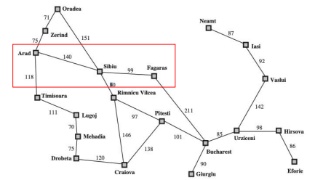

• What is missing? • **The cost of getting from the start node (Arad) to intermediate nodes**.

Greedy Best-First Search is Incomplete

• Start state: Iasi • Goal state: Fagaras

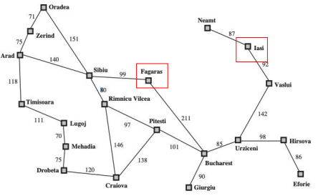

A* Search

• Proposed in 1968 by Peter Hart, Nils Nilsson and Bertram Raphael

• Most widely known form of Best-First Search.

• Combining **Uniform-Cost Search** **and Greedy Best-First Search** .

• f(n) = g(n) + h(n)

• g(n): the path cost from the start node to node n

• h(n): the estimated cost of the cheapest path from node n to the goal node

• When h(n) satisfies certain properties, A* is both complete and optimal!

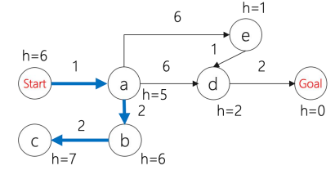

• **Uniform-cost** orders by path cost g(n)

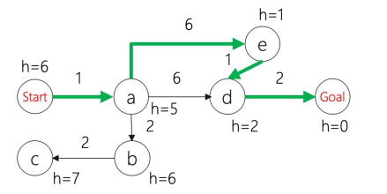

• **Greedy best first search** orders by estimated goal proximity h(n).

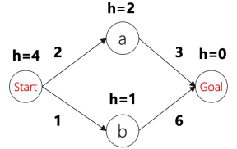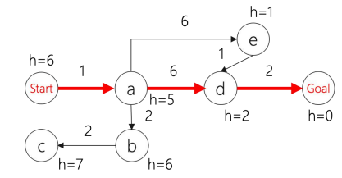

• **A* search combines** g(n) and h(n)

When to terminate in A* Search

• Similar to Uniform Cost Search, the goal test is applied to a node when it is selected for **expansion**,

• The path cost to the goal state may get **update**.

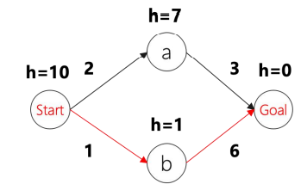Is A* Search Optimal?

• What went wrong?

• Actual goal cost < estimated goal cost

• Solution?

Need Some Conditions

• To guarantee that A* finds an **optimal solution**, we need that h(n) **never overestimates** the cost of reaching the goal

• Called an **admissible** (có thể chấp nhận được) heuristic

• Transfer to f, i.e., f also doesn't **overestimate**.

Formal Definition of Admissibility

• Let h*(n) be **the actual cost** to reach a goal from n.

•A heuristic function h is **optimistic** or **admissible** if 0 ≤ h(n) ≤ ℎ*(n) all nodes n.

•If h is **admissible**, then the A* algorithm will never return a sub-optimal goal node

Example: Admissible Heuristic

• Path finding: • the **straight-line distance** to Bucharest

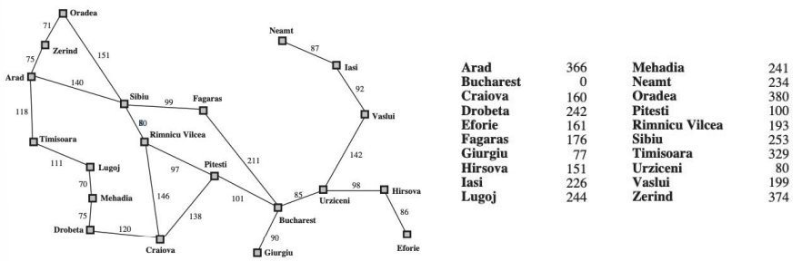

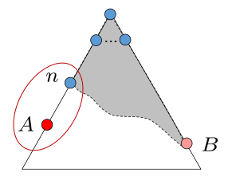Optimality of A* Tree Search Assume:

• A is an **optimal** goal node

• B is a **sub-optimal** goal node

• h is **admissible**

Claim: A will be expanded before B. 1. **f(n) is less or equal to f(A)**

Let h*(n) be the cheapest cost of getting to A from n

• h is admissible -> h(n) ≤ h*(n)

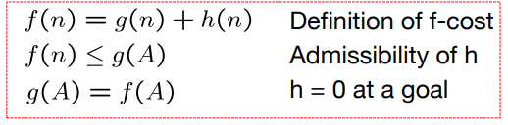• h*(n) = g(A) - g(n) -> h(n) ≤ g(A) - g(n) • -> f(n) ≤ f(A)

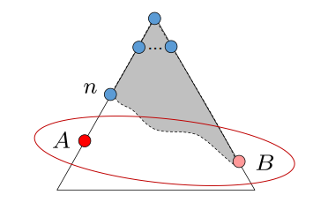Proof:

• Imagine B is on the frontier

• Some ancestor n of A is on the frontier, too (maybe A!)

• Claim: n will be expanded before B

1. f(n) is less or equal to f(A)

2. f(A) is less than f(B)

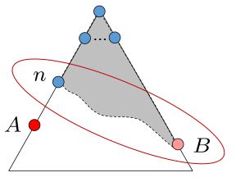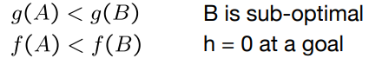

3. n expands before B

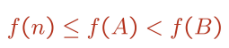

• **All ancestors of A expand before B --> A expands before B**

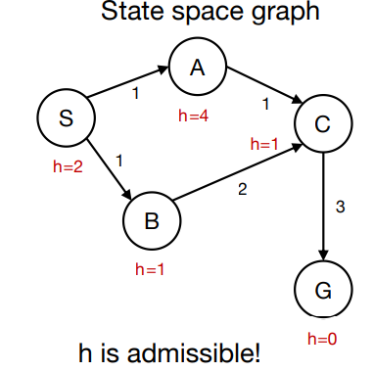A* Graph Search Gone Wrong

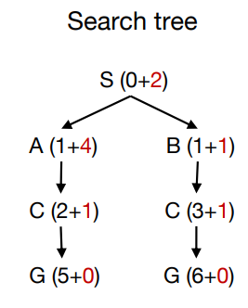

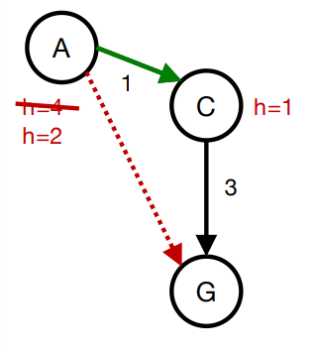Consistency (Tính nhất quán) of Heuristic

• Main idea: estimated heuristic costs ≤ actual costs

• Admissibility: heuristic cost ≤ actual cost to goal **h(A) ≤ actual cost from A to G**

• **Consistency**: heuristic “arc” cost ≤ actual cost for each arc **h(A) – h(C) ≤ cost(A to C)**

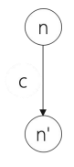Consequence of Consistency

• The f value along a path **never decreases**

f(n') = g(n') + h(n')

= g(n) + c + h(n')

≥ g(n) + h(n) consistency

= f(n)

• When A* **selects a node for expansion**, the **optimal path** to that node has been found.

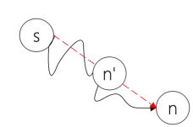• Proof:

• Assume g(n) > g*(n)

• Let n’ be the shallowest node in frontier on optimal path from s to n

• g(n') = g*(n') and f(n') = g*(n') + h(n')

• We have f(n') ≤ g*(n') + c(n' , n) + h(n) **consistency**

• f(n') ≤ g*(n) + h(n)

• f(n') < f(n) **contradiction**.

Optimality of A* Graph Search

• Consider what A* does with **a consistent heuristic**:

• Fact 1: A* expands nodes in nondecreasing total f value

• Fact 2: For every state s, nodes that reach s optimally are expanded before nodes that reach s suboptimal

• Result: **A* graph search is optimal**.

Summary

• Tree search:

• A* is optimal if heuristic is **admissible**

• UCS is a special case (h = 0)

• Graph search:

• A* optimal if heuristic is consistent

• UCS optimal (h = 0 is consistent)

• **Consistency implies admissibility**

• In general, most natural admissible heuristics tend to be consistent.

Intuition(trực giác) A*

• Let f* be the cost of optimal solution path.

• We have

• A* expands all nodes with f(n) < f*

• A* may then expand some nodes right on “goal contour” , with f(n) = f* before selecting a goal node.

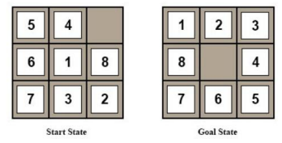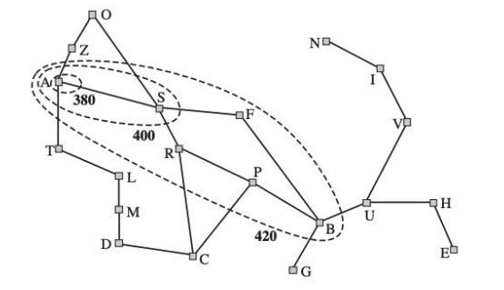

• A* Gradually adds "**f-contours**" of nodes

• Contour i has all nodes with f=fi, where fi < f i+1 .

Design of Heuristics

1. h1 = number of misplaced tiles

2. h2= Manhattan distance

• the sum of the distances of the tiles from their goal positions

Which one should we use? h1 ≤ h2 ≤h*

Importance of h(n) hc ≤ hm ≤ h*

• **Prefer** hm

• **Note:** Expand all nodes with f(n) = g(n) + h(n) < f*?

• **Every node with h(n) < f* - g(n) will be expanded**

• • Since h1 ≤ h2 , every node expanded with h2 will be expanded by h1 .

• Aside. How would we get an hopt?

Comparison of Search Costs on 8-Puzzle

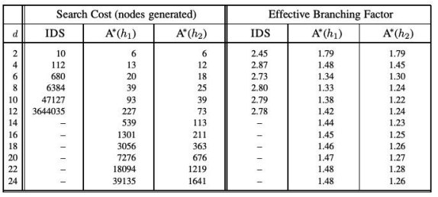

• Effective branch factor b*: characterize the quality of a heuristic N + 1 = 1 + b* +(b*)2 +….+(b*)d .

Where Does the Heuristics

• Most of the work in solving hard search problems optimally is in coming up with admissible heuristics

• Admissible heuristics: h(n) ≤ℎ*(n)

• But if ℎ*(n) is unknown, how can we verify the condition?

• Often, admissible heuristics are solutions to **relaxed problems**, where new actions are available -> **fewer constraints**

• The cost of an optimal solution to a relaxed problem is an admissible heuristic for the original

• The models obtained by such constraint-deletion processes are called **relaxed models**

Example: 8 Queen

• Description of actions: A tile can move from square A to square B if A is adjacent to B and B is blank

(a) A tile can move from square A to square B if A is adjacent to B.

(b) A tile can move from square A to square B if B is blank

(c) A tile can move from square A to square B

Example: Traveling Salesman Problem

• Find the shortest route that visits each city exactly once and returns to the origin city

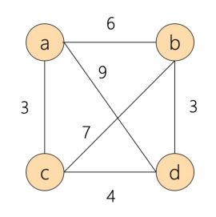

• Find an estimate for the cheapest path that starts at a city X, ends at city Y, and go through each unvisited city.

Example: Traveling Salesman Problem

• Find an estimate for the cheapest path that starts at a city X, ends at city Y, and go through each unvisited city.

• Three conditions for the path:

• Being a graph • Being connected • Being degree 2.

• Find an estimate for the cheapest path that starts at a city X, ends at city Y, and go through each unvisited city.

• Three conditions for the path:

• Being a graph -> Optimal Assignment Problem

• Being degree 2

• Find an estimate for the cheapest path that starts at a city X, ends at city Y, and go through each unvisited city.

• Three conditions for the path: • Being a graph • Being connected -> Minimum Spanning Tree Problem

Consistency

• Heuristics come from **relaxed problems** are guaranteed to be **consistent**.

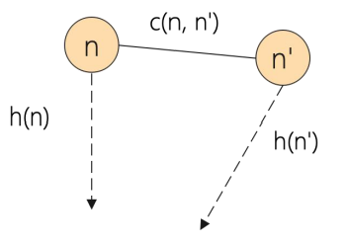

• h(n) and h(n') stand for the minimum cost of finding solution for some relaxed problem. We have

h(n) ≤ **c'(n, n')** + h(n') relaxed cost -> h(n) ≤ c(n, n') + h(n)

What if We Have Multiple Heuristics

• Suppose we have heuristics h1 (n), h2 (n), h3 (n)

• Every node with h(n) < f* - g(n) will be expanded

• The final heuristic h(n) = max(h1 (n), h2 (n), h3 (n)).

A* Applications

• Video games • Pathing / routing problems • Resource planning problems • Robot motion planning • Language analysis • Machine translation • Speech recognition.

A*: Summary

**Optimal**: Yes A* is optimally efficient: given the information in h, no other optimal search method can expand fewer nodes

**Complete:** Unless there are infinitely many nodes with f(n) < f*. Asussme locally finite: (1) finite branching, (2) every operator costs at least ε >0

**Complexity (time and space**): still exponential because of breadth-first nature. Unless |h(n) - h*| <= O(log(h*(n)), with h true cost of getting to goal, the time complexity is polynomial.

Link: [https://vi.wikipedia.org/wiki/Gi%E1%BA%A3i_thu%E1%BA%ADt_t%C3%ACm_ki%E1%BA%BFm_A*](https://vi.wikipedia.org/wiki/Gi%E1%BA%A3i_thu%E1%BA%ADt_t%C3%ACm_ki%E1%BA%BFm_A*)

. <https://vi.wikipedia.org/wiki/Heuristic#:~:text=Heuristic%20(%2Fhj%CA%8A%C9%99%CB%88r%C9%AA,%C4%91%E1%BA%A3m%20b%E1%BA%A3o%20l%C3%A0%20t%E1%BB%91i%20%C6%B0u>.

.

<https://en.wikipedia.org/wiki/Consistent_heuristic#:~:text=In%20the%20study%20of%20path,cost%20of%20reaching%20that%20neighbour>.

**Local Search**

Search Algorithms

•BFS, DFS, UCS, A* etc

• Explore the state-space **systematically** to the goal state

• Need to reconstruct the **path**.

Local Search Methods

• The search spaces for some real-world problems is **enormously big**

• How many combinations can 500 processes be assigned to 100 computers? 100500 states

• There are 3361 states in Go board

• A completely different kind of method is called for: • Local Search Methods

Local Search Methods

• Applicable when we're interested in the Goal State -- **not in how to get there**

• E.g. N-Queens, Course Scheduling Problem or Job-shop Scheduling

• Basic idea:

- use a single current state

- don't save paths followed

- generally move only to sucessors/neighbors of that state

- find the best state according to an objective function or cost function

Local Search Methods

• Advantages:

• Use very little memory

• Can be applied to problems with a large number of states

• Can be applied to problems with changing state spaces

• Disadvantages:

• Cannot recover the path

• The solution may not be optimal

State-Space Landscape

• Local Search Methods rely on an objective function or a cost function to compute the state-space landscape

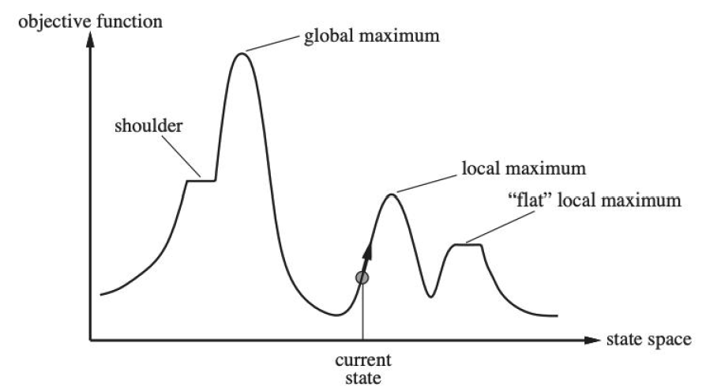

• Local search algorithms explore this landscape

Hill Climbing Search

• Move in the direction of increasing value

• Terminate when it reaches a “peak” where no neighbor has a higher value.

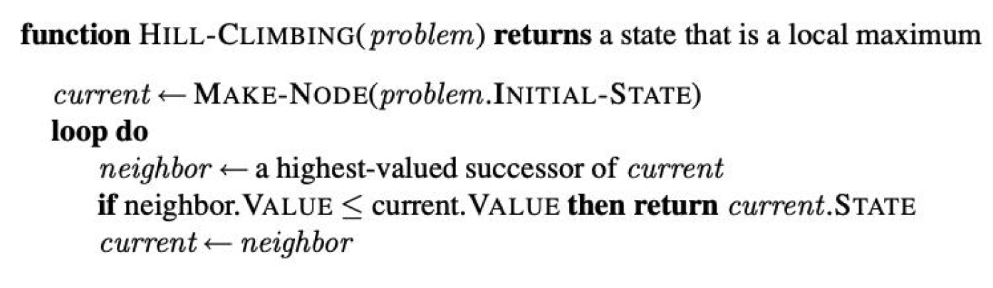

• Only need to record the state and the value of the objective function or cost function

• **Similar to greedy algorithm**, **only check the value of the immediate neighbors**

• Rely on **complete-state formulation** instead of incremental formulation

Complete-State Formulation vs. Incremental Formulation

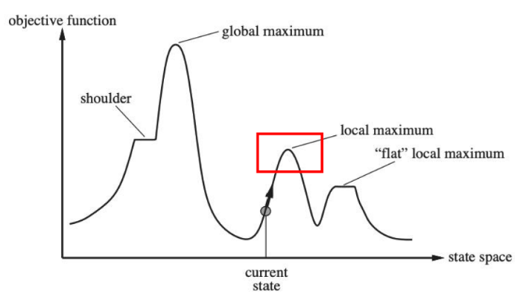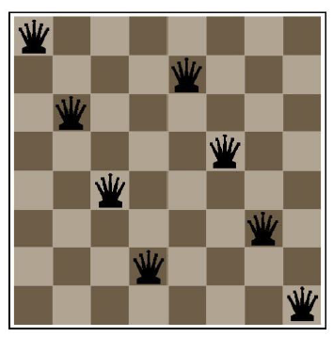

• Complete-State Formulation

• **All queens are in the board**. Move any queen in the same column

• **Why used in local search**? -> Divide object function

• Incremental Formulation

• Add each queen to the board one by one (used in many search algorithms we covered before)

Hill Climbing Search Can Get Stuck

• Local maxima

• A peak that is higher than all its neighbors but lower than the global maximum.

• Ridges: • A sequence of local maxima

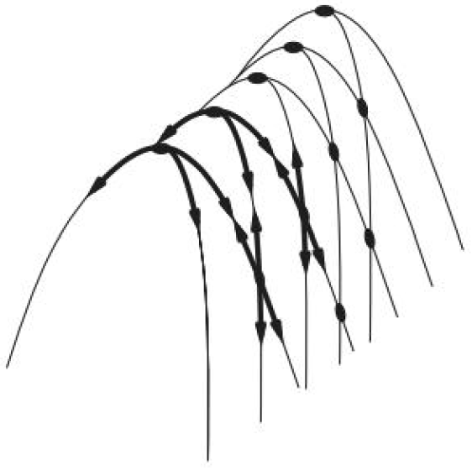

• Plateaux or shoudlers • The objective function is constant

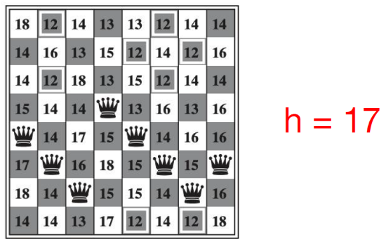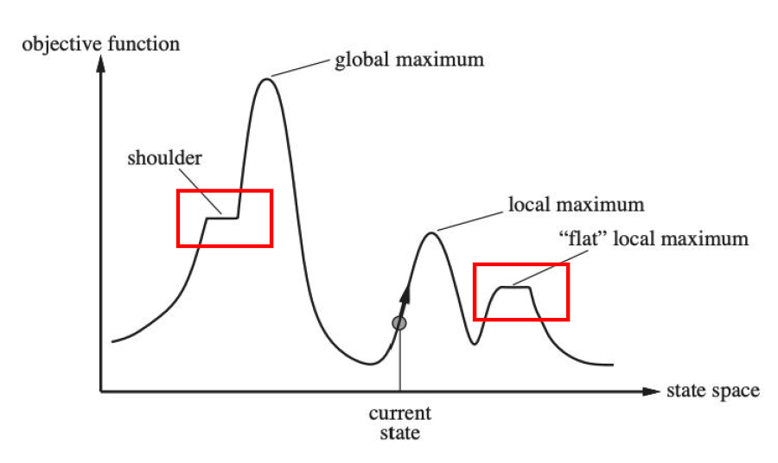

Example: 8-queen problem

• Put n queens on an n × n board with no two queens on the same row, column, or diagonal

• What is the **state-space** of this problem?

• How is this problem different from the 8-puzzle problem?

Example: 8-queen problem

• Heuristic cost function: the number of pairs of queens that are attacking each other, either directly or indirectly

• Each time we can move the queen to another square in the same column

Example: 8-queen problem

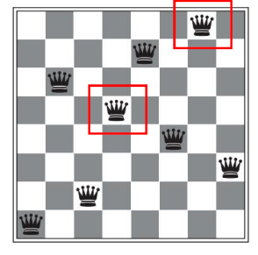• Heuristic cost function: the number of pairs of queens that are attacking each other, either directly or indirectly

• Local minimum with h =1

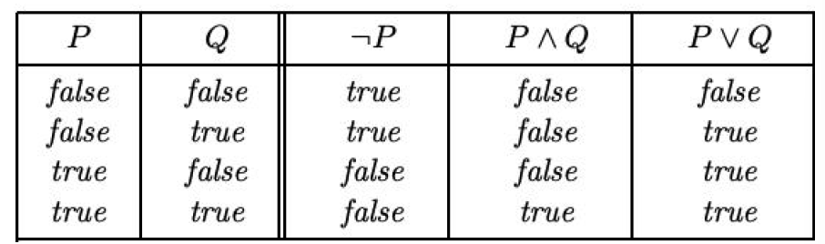Example: Satisfiability

• Propositional logic:

• Literals (**True or False**) A, B, C, ...

• Logical connectives: 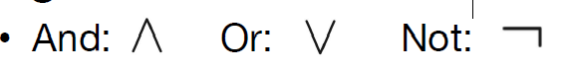

• Clause: a disjunction of literals 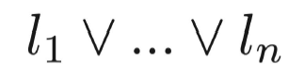

• Conjunctive normal form: 

Example: Satisfiability

• A wide variety of key CS problems can be translated into a propositional logical formalization

e.g., 

• Solved by finding a truth assignment to the propositional variables (A,B,C,…) that makes it true, i.e., a model.

• If a formula has a model, we say that it is “satisfiable”

Example: Satisfiability Testing

• Best-known method: Davis-Putnam Procedure (1960)

- Backtrack search (DFS) through the space of truth assignments

• Assigning values to variables one by one and simplifying at each step

• Cannot be satisfied 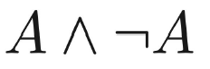

Example: Satisfiability Testing

Best-known method**: Davis-Putnam Procedure** (1960): <https://www.youtube.com/watch?v=ENHKXZg-a4c>

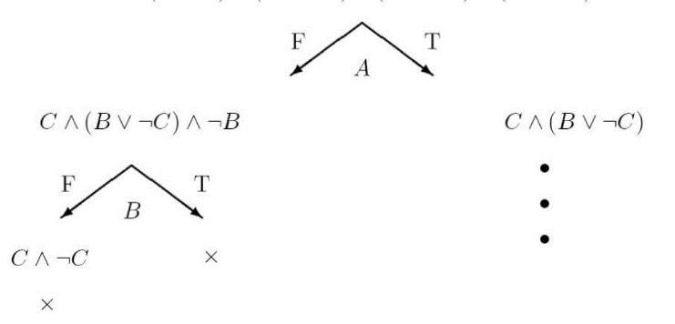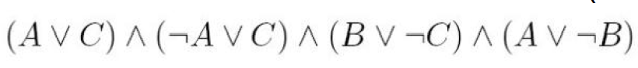

• To date, Davis-Putnam Procedure is still the fastest sound

and complete method.

• However, there are classes of formulas where the procedure

scales badly.

• Consider an incomplete local search procedure

Greedy Local Search -- GSAT

• Begin with a random truth assignment (assume CNF).

• Flip the value assignment to the variable that **yields the greatest number of satisfied clauses**. (Note: Flip even if there is no improvement.)

• Repeat until a model is found, or have performed a specified maximum number of flips.

• If a model is still not found, repeat the entire process, starting from a different initial random assignment.

• Input: a conjunctive normal form α, MAX-FLIPS, MAX-TRIES

• Output: a satisfying truth assignment if found

• For i = 1 to MAX-TRIES:

T := **a randomly generated truth assignment**

For j = 1 to MAX-FLIPS:

If T satisfies α, then return T

p := **a propositional variable such that a change of its truth leads to the largest number of satisfied clauses**

T := **T with the truth value of p reversed**

return “no satisfying assignment found”

Greedy Local Search -- GSAT

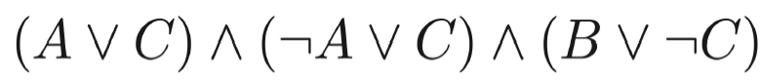

• A: False B: False C: True

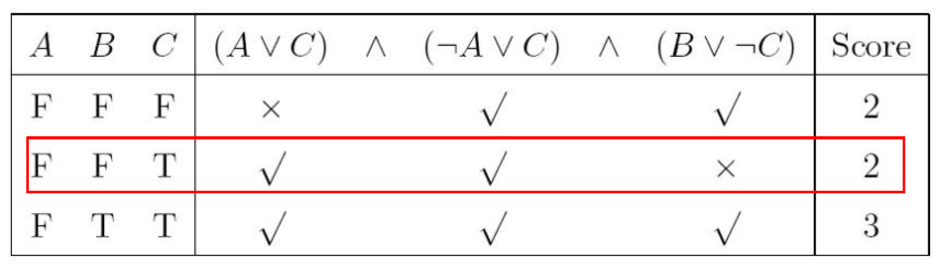

How well does it work?

• First intuition: It wil get stuck in local minima, with a few unsatisfied clauses.

• Note we are not interested in almost satisfying assignments

• E.g., a plan with one “magic” step is useless.

• Contrast with optimization problems.

• GSAT is not complete.

• **Surprise:** It often finds global minimum!

• i.e., finds satisfying assignments

• Generate a large number of random formulas

• Different number of propositional variables

• Different number of clauses

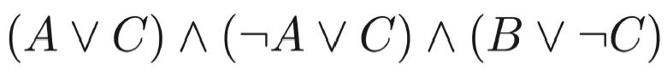

• Run GSAT and Davis-Putnam Procedure on the generated formulas and measure the time to find the right assignment.

Greedy Local Search – GSAT

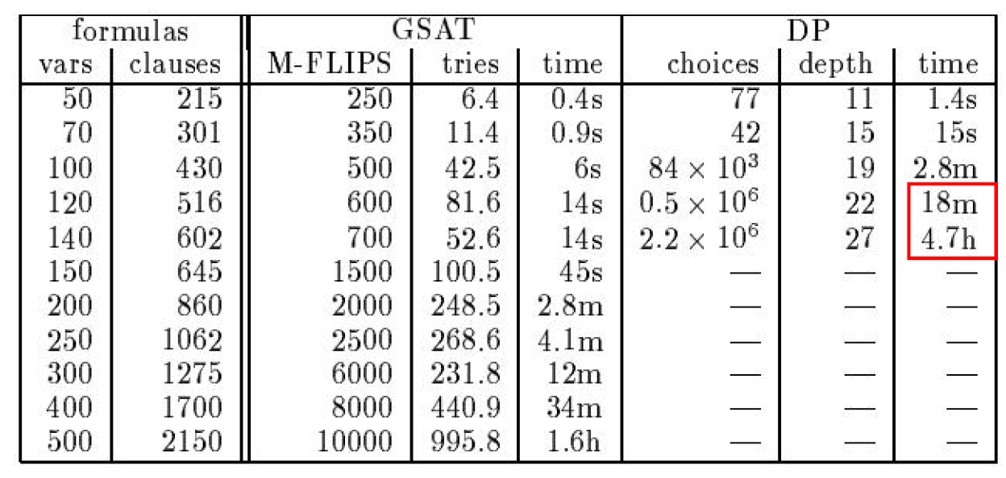

Limitations of GSAT



• Can be satisfied only when A is True

• But GSAT prefers a negative assignment

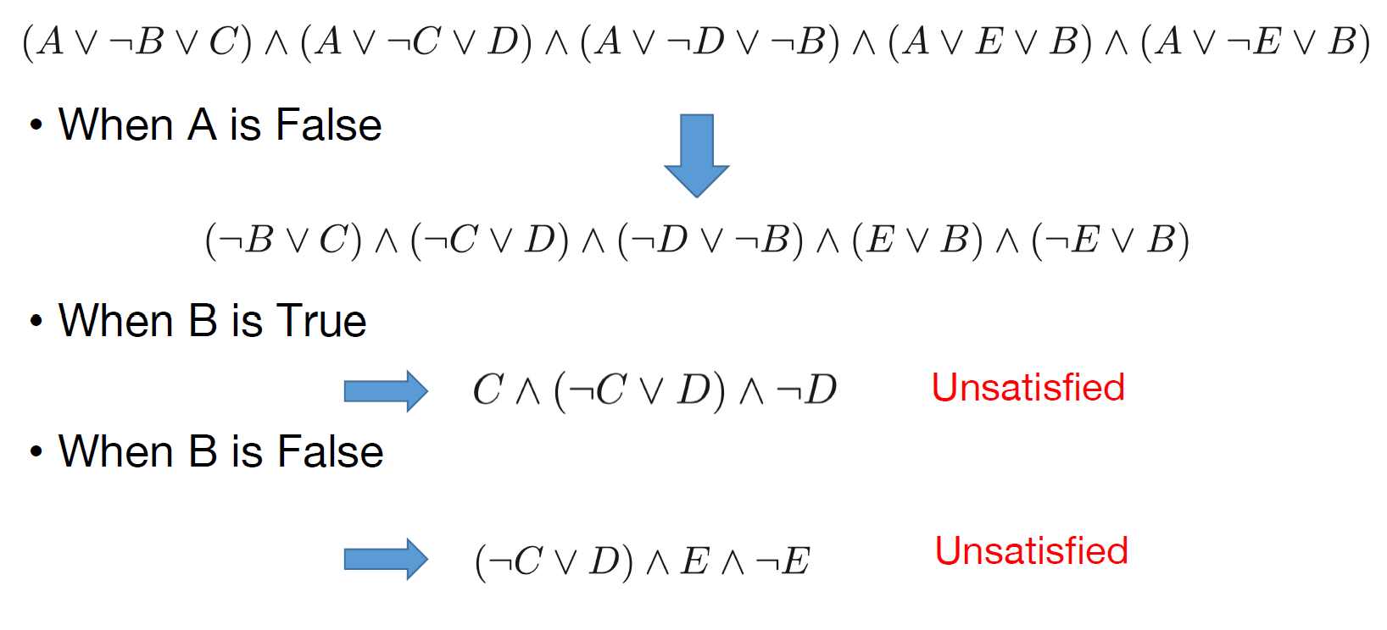

HCS:

<https://www.youtube.com/watch?v=oSdPmxRCWws>

<https://www.youtube.com/watch?v=rTcRLIxCxVs>

Best-known method**: Davis-Putnam Procedure** (1960): <https://www.youtube.com/watch?v=ENHKXZg-a4c>

GSAT: <https://www.youtube.com/watch?v=SAXGKCnOuP8>

**Local Search**

Improvements to Basic Local Search

• Issue: How to move more quickly to successively higher plateaus and avoid getting “ stuck” / local minima

• Idea: Introduce uphill moves (“ noises”) to escape from long plateaus (or true local minima).

• Strategies: • Simulated Annealing • Random-restart hill-climbing • Tabu search • Local beam search • Genetic Algorithms.

Variation on Hill-Climbing

• Random restarts: simply restart at a new random state after a pre-defined number of local steps

• Tabu: prevent returning quickly to the same state. • Implementation: Keep fixed length queue (“tabu list”): add most recent step to queue; drop “oldest” step. Never make step that’s currently on the tabu list

• **Uphill moves are acceptable** if no downhill moves are available.

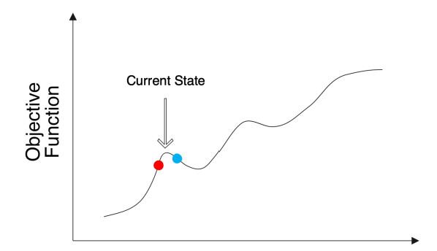Simulated Annealing

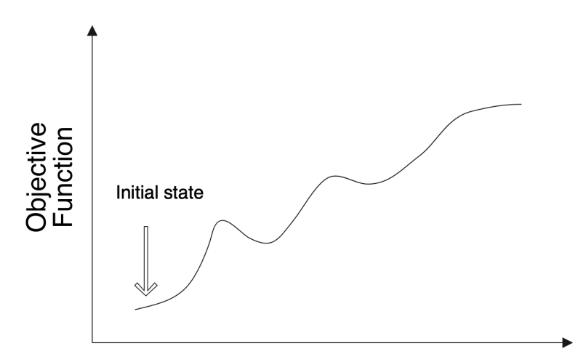

• Idea: • Use conventional hill-climbing techniques, but occasionally take a step in a direction **other than that in which the rate of change is maximal**.

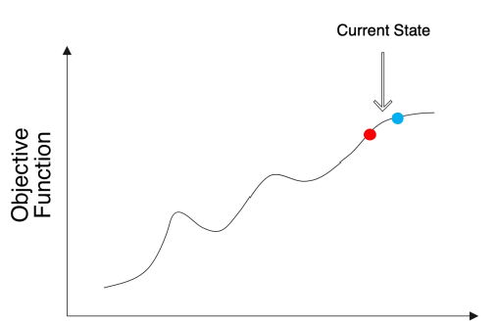

As time passes, • The size of any down-hill step taken is **decreased**.

• The probability that a down-hill step is taken is gradually reduced

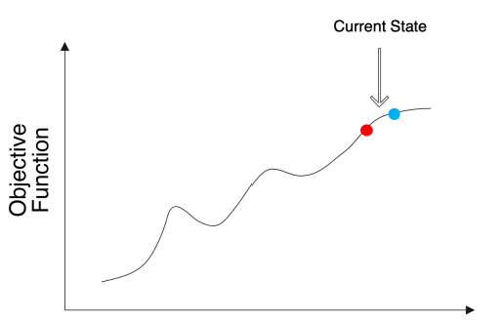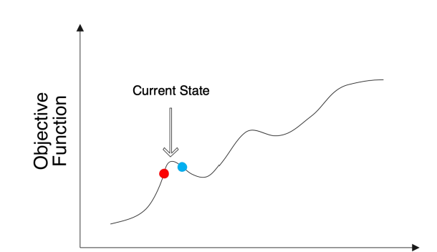

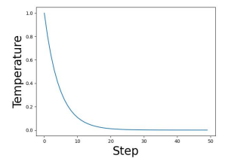Simulated Annealing

• Intuition:

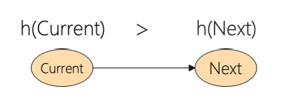

• The probability of move to a bad state should decrease exponentially with the “badness” h(Next) - h(Current)

• The probability decreases as the “temperature” T goes down

• How to schedule the “temperature”? • Initially with a high temperature and gradually decays

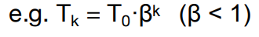

SA Algorithm

• Current, Next: nodes/states

• T: “temperature” controlling probability of downward steps

• Schedule: mapping from time to “temperature”

• H: heuristic evaluation function.

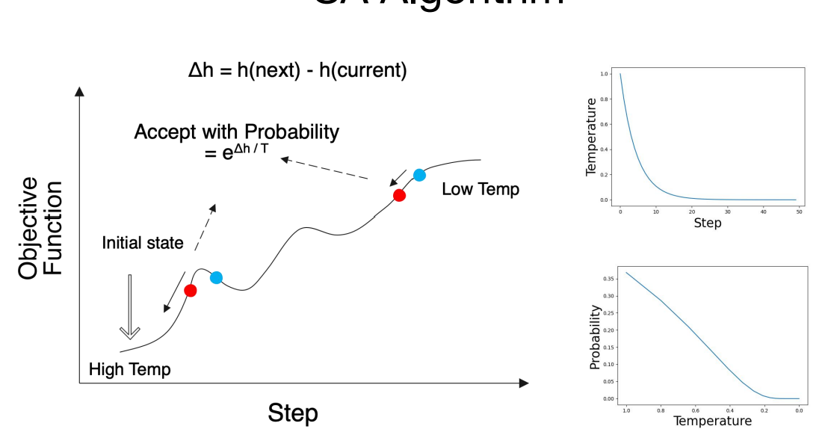

current ← initial state

for t ← 1 to inf do

T ← schedule[t]

if T = 0 then return current

next ← randomly selected successor of current

Δh ← h(next) - h(current)

if Δh > 0 then current ←next uphill

else current ← next only with probability eΔh/T downhill.

SA Algorithm: Convergence

• If the schedule lowers T slowly enough, SA will find a global minimum with probability approaching 1

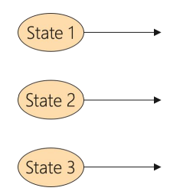• In practice, reaching the global minimum could take a large number of iterations.

Local Beam Search

• Instead of maintaining one current state, local beam search **keep track of k states**

• **All of the successors** of the k states are generated

• Local beam search selects the **best k states** from all the successors and repeat until the goal state is found.

• Useful information is passed among the parallel search threads

• Disadvantage: • All k states can become stuck in a small region of the state space

Example: Satisfiability

• A wide variety of key CS problems can be translated into propositional logical formalization

e.g., 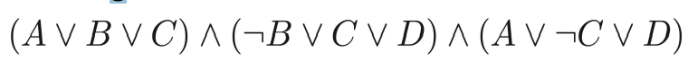

• Solved by finding a truth assignment to the propositional variables (A,B,C,…) that make it true, i.e., a model.

• If a formula has a model, we say that it is “satisfiable”

Random Walk SAT

Random walk SAT algorithm: 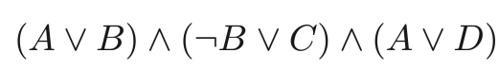

I Pick random truth assignment.

II Repeat until all clauses satisfied:

Flip variable from any unsatisfied clause.

Solve 2-SAT (2 variables per clause) in O(n2) flips

Does not work at all for hard k-SAT (k >= 3)

Walk SAT: Mixing Random Walk w/ Greedy Search(Selman et al. 1996)

• With probability p, walk, i.e., pick a variable in some unsatisfied clause and flip it;

• With probability (1-p) make a **greedy** flip, i.e., one that makes greatest decrease in number of unsatisfied clauses.

• Cannot detect **un-satisfiability**.

Experimental Results: Hard Random 3CNF

• Noise: different from Walk SAT, the selected randomly flipped variable is not restricted to be in an unsatisfied clause

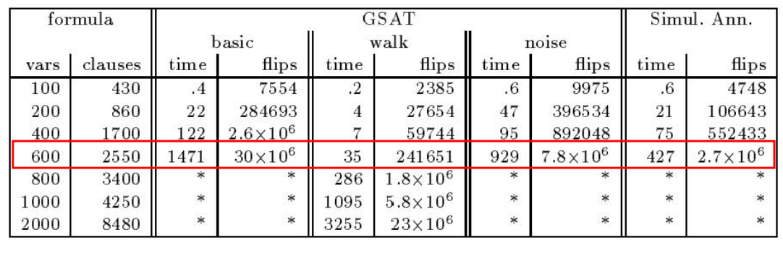

• Complete methods, such as DP, up to 400 variables

• **Walk SAT** better than **Simulated Annealing** better than **Basic GSAT** better than **Backtracking (Davis-Putnam)**.

Local Search in continuous Spaces

• Originated in the 17th century, after the development of calculus by Newton and Leibniz.

Min f(x1, x2,x3,…). 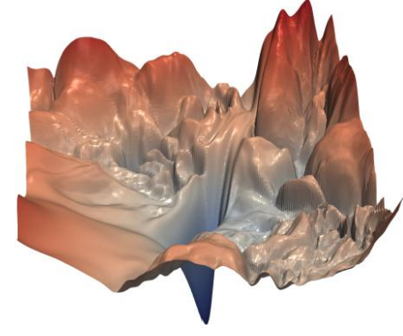

• Example: • Place a storage center (x, y) that are close to n cities(ai ,bi).

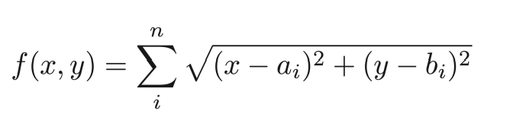

Gradient Descent

• Similar to hill-climbing search but the states are continuous

• Basic idea:

• Use the gradient of the cost function for updating the unknowns. 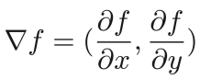

• The gradient gives the direction for decreasing the objective function.

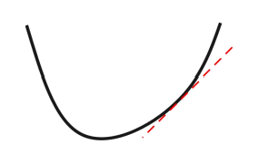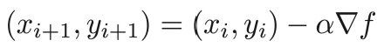

• For small enough α, we have

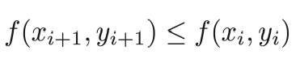

**Local Search**

Genetic Algorithms

• Approach mimics evolution

• Usually presented using a rich (and different) vocabulary:

- fitness, populations, individuals, genes, crossover, mutations, etc.

• Still, can be viewed quite directly in terms of standard local search.

Features of Evolution

• High degree of parallelism

• New individuals (“ next state / neighboring states”):derived from “ parents” (“ crossover operation”)genetic mutation

• Selection of next generation based on survival of the fittest.

General Idea of Genetic Search

• Maintain a population of individuals (states/ strings/candidate solutions)

• Similar to local beam search

• Each individual is evaluated using a fitness function ,i.e., an evaluation function. The fitness scores force individuals to compete for the privilege of survival and reproduction.

• Similar to hill climbing

• Generate a sequence of generations:

• From the current generation, select pairs of individuals(based on fitness) to generate new individuals, using crossover

• Introduce some noise through random mutations

• Hope that average and maximum fitness(i.e., value to be optimized) increases over time

Genetic Algorithms as Search

• Genetic algorithms are **local heuristic search algorithms**.

• Especially good for problems that have large and poorly understood search spaces

• Genetic algorithms use a **randomized parallel beam search** to explore the state space

• You must be able to define **a good fitness function**, and of course, **a good state representation**.

Binary String Representation

• Individuals are usually represented as **a string over a finite alphabet**, usually bit strings.

• Individuals represented can be **arbitrarily complex**.

• E.g. each component of the state description is allocated a specific portion of the string, which encodes the values that are acceptable.

• Bit string representation allows **crossover** operation to change multiple values in the state description. **Crossover** and **mutation** can also produce previously unseen values.

8-queens State Representation

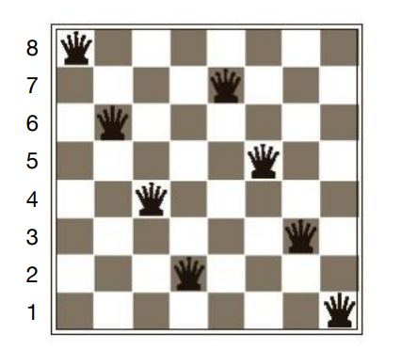

• Option 1: 86427531 • Option 2: 111 101 011 001 110 100 010 000

GA: High-level Algorithm

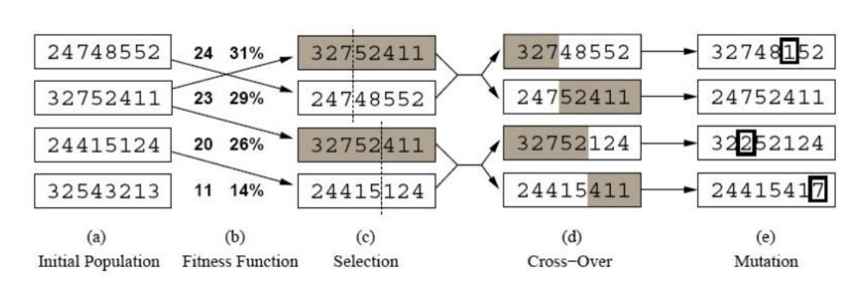

Selecting the Most Fit Individuals

• Individuals are chosen probabilistically for survival and **crossover** based on fitness proportionate selection:

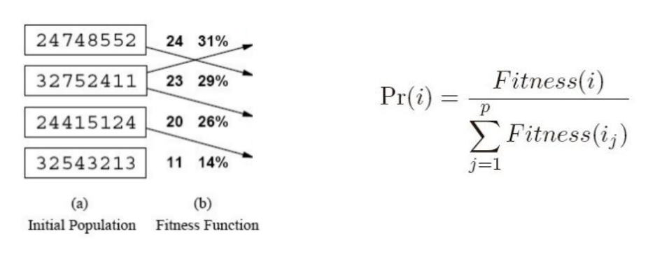

Other Selection Methods

• Tournament Selection:

• Two individuals selected at random. **With probability** p ,the more fit of the two is selected. **With probability**(1−p), the less fit is selected.

• Rank Selection:

• The individuals **are sorted by fitness** and the probability of selecting an individual is proportional to its rank in the list.

Crossover Operators

•Single-point crossover:

Parent A: 1 0 0 1 0 1 1 1 01

Parent B: 0 1 0 1 1 1 0 1 10

Crossover Operators

•Single-point crossover:

Parent A: 1 0 0 1 0 1 1 1 01

Parent B: 0 1 0 1 1 1 0 1 10

Child AB: 1 0 0 1 0 1 0 1 10

Child BA: 0 1 0 1 1 1 1 1 01

Crossover Operators

• Two-point crossover:

Parent A: 1 0 0 1 0 1 1 1 01

Parent B: 0 1 0 1 1 1 0 1 10

Crossover Operators

• Two-point crossover:

Parent A: 1 0 0 1 0 1 1 1 01

Parent B: 0 1 0 1 1 1 0 1 10

Child AB: 1 0 0 1 1 1 0 1 01

Child BA: 0 1 0 1 0 1 1 1 10

Crossover Operators

• Uniform crossover:

Parent A: 1 0 0 1 0 1 1 1 01

Parent B: 0 1 0 1 1 1 0 1 10

Child AB: 1 1 0 1 1 1 1 1 01

Child BA: 0 0 0 1 0 1 0 1 10

Mutation

• Mutation: randomly flip one bit

Individual A: 1 0 0 **1** 0 1 1 101

Individual A': 1 1 0 **0** 0 1 1 101

Mutation

• The mutation operator introduces random variations, allowing solutions to jump to different parts of the search space.• What happens if the mutation rate is too low?

• What happens if the mutation rate is too high?

• A common strategy is to use a high mutation rate when search begins

• But to decrease the mutation rate as the search progresses.

GA: High-level Algorithm

GA(Fitness, Fitness theshold, p, r, m)

P ← randomly generate p individuals

For each i in P, compute Fitness(i)

While [ max Fitness(i) < Fitness theshold]

1. Probabilistically select (1 − r)p members of P to add to Ps

2. Probabilistically choose r · p / 2 pairs of individuals from P. Foreach pair <i1,i2> apply **crossover** and add the offspring to Ps

3. **Mutate** m · p random members of Ps

4. P ← PS 5. For each i in P, compute Fitness(i) Return the individual in P with the highest fitness.

Example

• Maximize the function f(x) = x3 , where x ∈[0, 15]

Step 1: Choose an encoding 0 15

↓ ↓

0000 1111

Step 2: Randomly choose an initial population 4, 7, 9, 12

Step 3: Select parents

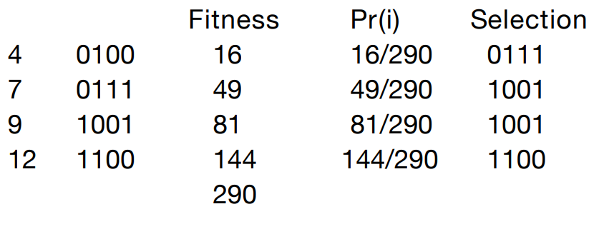

Step 4: Crossover and Mutation

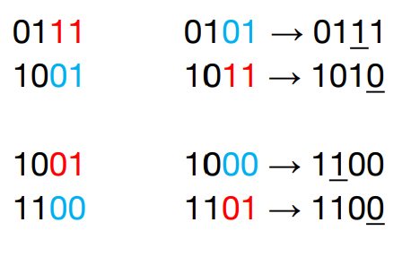

Step 5: Evaluate the offspring

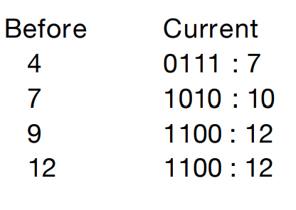

How Does Genetic Algorithm Work?

• Based on the idea of schema

• For example, 246***** is a schema for 8-queenproblem

• 11** is a schema for the optimization problem

• Each schema can be thought as a **building block** of the final solution

• If the average fitness of the instances of a schema is **above the mean**, then the number of instances of the schema within the population will **grow over time**.

Limitations of GA

•It is expensive to evaluate the fitness function

• The stopping criterion is not clear

• Can get stuck in local minimum

Genetic Programming

• In Genetic Programming**, programs** are evolved instead of **bit strings**.

• We want to find the program that completes the task we have.

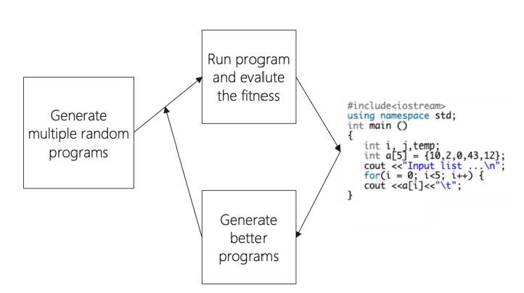

Genetic Programming

• In Genetic Programming, programs are evolve dinstead of bitstrings.

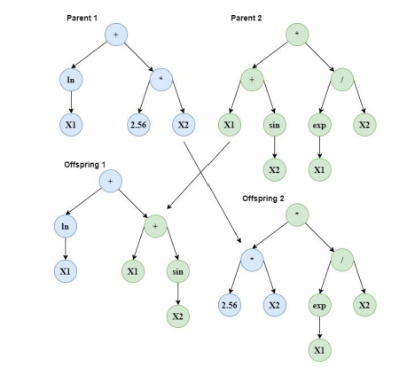

Remarks on GA’s

• In practice, several 100 to 1000’s of strings. Value of **crossove**r difficult to determine (so far).

• Crowding can occur when an individual that is much more fit than others reproduces like crazy, which **reduces diversity** in the population.

• In general, GA’s are highly sensitive to the representation

**Constraint Satisfaction Problem**

Standard Search Problem

* **Standard Search Problems**:
  + State is a “black box”: **arbitrary** data structure
  + Goal test can be **any** function over states
  + Successor function can also be **anything**

Constraint Satisfaction Problems (CSP)

* Constraint satisfaction problems (CSPs):
  + A special subset of search problems
  + State is defined by variable Xi with values from a domain D (sometimes D depends on i)
  + Goal test is a set of constraints specifying allowable combinations

of values for subsets of variables

* Why CSPs?
  + Allows useful general-purpose algorithms with more power than standard search algorithms

Example: Map-Coloring Problem

* 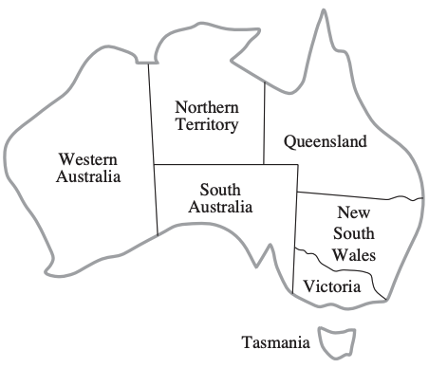Color each region either red, green or blue in such a way that no neighboring regions have the same color
  + **Variables**: different regions
  + **Domains**: colors

Constraint Satisfaction Problems (CSP)

* A **powerful** representation for (discrete) search problems.
* A Constraint Satisfication Problem (CSP) is defined by:
  + **X** is a set of n variables X1, X2, ...., Xn, each defined by a finite domain D1, D2, ..., Dn of possble values
  + **C** is a set of constraints C1, C2, ..., Cm. Each Ci involves some subset of the variables; specifices the allowable combinations of values for that subset.

A **solution** is an assigment of values to the variables that **satisfies all constraints.**

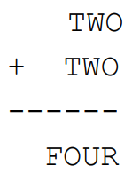Cryptarithmetic as a CSP

* **Variables**:

F O U R T W C1 C2 C3

* **Domains**:

{0, 1, 2, 3, 4, 5, 6, 7, 8, 9}

* **Constraints**:

O + O = R + 10 * C1

C1 + W + W = U + 10 * C2

C2 + T + T = O + 10 * C3

C3 = F

**alldiff**(F, O, U, R, T, W)

Cryptarithmetic Constraint Graph

* 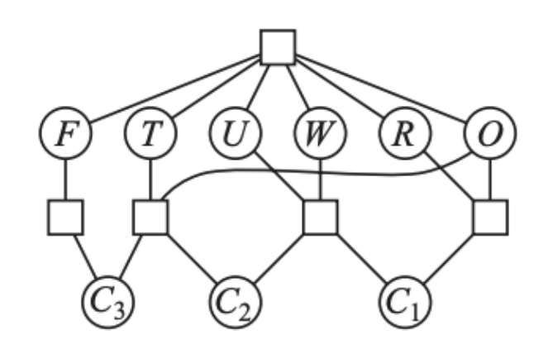Variables: F O U R T W C1 C2 C3
* Domains:

{0, 1, 2, 3, 4, 5, 6, 7, 8, 9}

* Constraints:

O + O = R + 10 * C1

C1 + W + W = U + 10 * C2

C2 + T + T = O + 10 * C3

C3 = F

**alldiff**(F, O, U, R, T, W)

Map-Coloring Problem

* **Variables:** WA, NT, Q, NSW, V, SA, T
* **Domains**: {red, green, blue}
* **Constraints**:

Adjacent regions must have **diffe-**

**rent** colors

Implicit: WA $≠$ NT

Explicit: (WA, NT) $∈$ {(red, green), {red, blue}, ...}

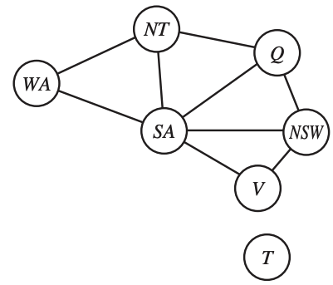Constraint Graph

* **Variables**:

WA, NT, Q, NSW, V, SA, T

* **Domains**:

{red, green, blue}

* **Constraints**:

Adjacent regions must have **diffe-**

**rent** colors

Implicit: WA $≠$ NT

Explicit: (WA, NT) $∈$ {(red, green), {red, blue}, ...}

Map-Coloring Problem

* **Variable**s:

WA, NT, Q, NSW, V, SA, T

* **Domains**:

{red, green, blue}

* **Constraints**:

Adjacent regions must have **diffe-**

**rent** colors

Implicit: WA $≠$ NT

Explicit: (WA, NT) $∈$ {(red, green), {red, blue}, ...}

Varieties of CSPs

* **Discrete variables**
  + **Finite domains:** each variable can be only assigned to **finite** number of values.
  + 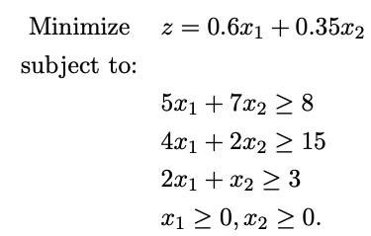**Infinite domains:** each variable can be assigned to infinite number of values, e.g., set of integers
* **Continuous variables**
  + Linear programming

Varieties of Constraints

* **Unary constraints** involve a single variable (equivalent to reducing domains), e.g.:
  + SA ≠ Green
* **Binary constraints** involve pairs of variables, e.g.:
  + SA ≠ WA
* **Higher-order constraints** involve 3 or more variables
* **Preferences** (soft constraints):
  + E.g., red is better than green

Real-World CSPs

* **Assignment problems**
  + e.g., who teaches what class
* **Timetabling problems**
  + e.g., which class is offered when and where?
* **Transportation scheduling**
* **Factory scheduling**

Constraint Satisfaction Problems (CSP)

* For a given CSP the problem is one of the following:
  + Find **all** solutions
  + Find **one** solution
  + The **optimal** solution given an objective function
  + Determine if a solution **exists**

How to View a CSP as a Search Problem?

* **Initial State** -- state in which all the variables are **unassigned**.
* **Successor function** -- assign a value to a variable from a set of possible values.
* **Goal test** -- check if all the variables are assigned and all the constraints are satsified. We call the assignment is complete.
* **Path cost** -- assumes constant cost for each step

Backtracking Search

* Depth-first search for CPSs with single-variable assigments is called backtracking search

- Backtracks when a variable has no legal values left to assign

**Backtracking search** is the basic uninformed algorithm for CSPs.

The Backtracking Search Algorithm

**Backtrack**(assignment, csp):

**If** assignment is complete **then return** assignment

var ← select one unassigned variable

**for** each value **in** the domain of var **do**

**if** value is consistent with assignment **then**

add {var = value} to assignment

result ← **Backtrack**(assignment, csp)

**if** result ≠ failure **then**

**return** result

remove {var = value} from assignment

**return** failure

Backtracking Example



The Backtracking Search Algorithm

**Backtrack**(assignment, csp):

**If** assignment is complete **then return** assignment

var ← select one unassigned variable ← which one to select?

**for** each value in the domain of var **do** ← which one to use?

**if** value is consistent with assignment **then**

add {var = value} to assignment ← detect failure early

result ← **Backtrack**(assignment, csp)

**if** result ≠ failure **then**

**return** result

remove {var = value} from assignment

**return** failure

Improving Backtracking Efficiency

General-purpose methods can give huge gains in speed:

1. Which variable should be assigned next?

* + Choose the **most constrained variable**, and break ties by choosing the **most constraining variable**

2. In what order should its values be tried?

* + Choose the **least constraining value**

3. Can we detect inevitable failure early?

* + Forward checking, constraint propagation

Improving Backtracking Efficiency

1. Which variable should be assigned next?

* + Choose the **most constrained variable**, and break ties by choosing the **most constraining variable**

Variable Selection Heuristic 1: Most Constrained Variable

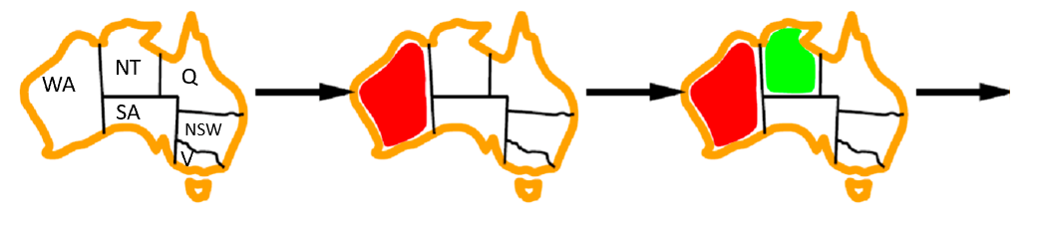

**Most constrained variable**:

Choose the variable with the fewest legal values a.k.a**. mininum remaining values (MRV)** heuristic

* Why min rather than max?
* “Fail-fast” ordering
* 1000× faster or more

Variable Selection Heuristic 2: Most Constraining Variable

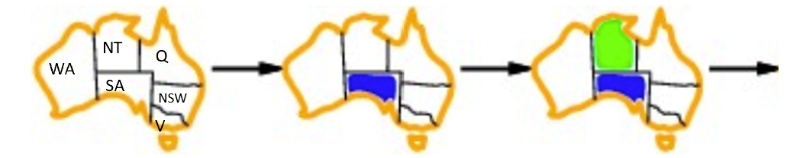

* Tie-breaker among most constrained variables

**Most constraining variable**:

* choose the variable with the most constraints on remaining variables

Improving Backtracking Efficiency

2. In what order should its values be tried?

Choose the **least constraining value**

Value Select Heuristic: Least Constraining Value

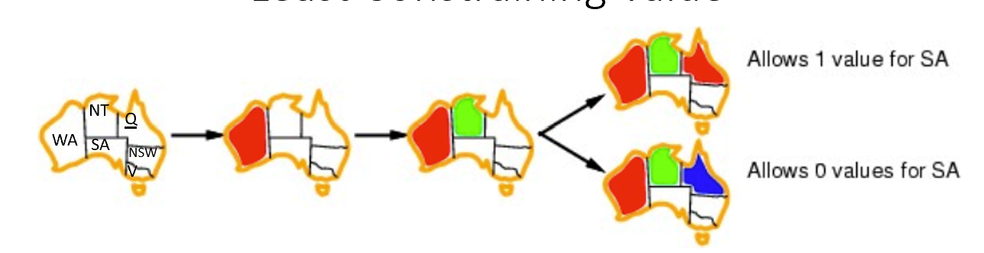

* Given a variable, choose the **least constraining value**:

the one that rules out the fewest values in the remaining variables

* Why least rather than most?

Variable and Value Ordering Heuristics

* The heuristics should be applied whenever a **variable/value** needs be chosen during the search process
* They should **not** be applied once and for all at the beginning of the search process

Improving Backtracking Efficiency

3. Can we detect inevitable failure early?

* + Forward checking, constraint propagation

Consistency-Enforcing Procedure 1: Forward Checking

* Idea:

Keep track of **remaining legal values** for **unsigned variables**

Terminate search when any variable has no legal values.

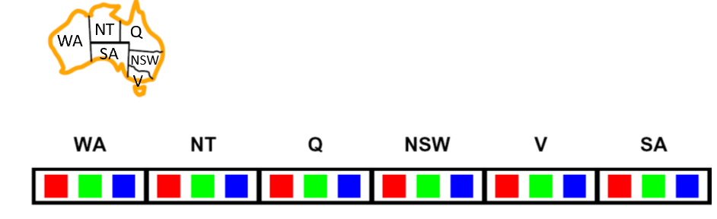

Consistency-Enforcing Procedure 2: Constraint Propagation

* Forward checking propagates information from **assigned** to **unassigned** variables, but doesn't provide early detection for all failures:

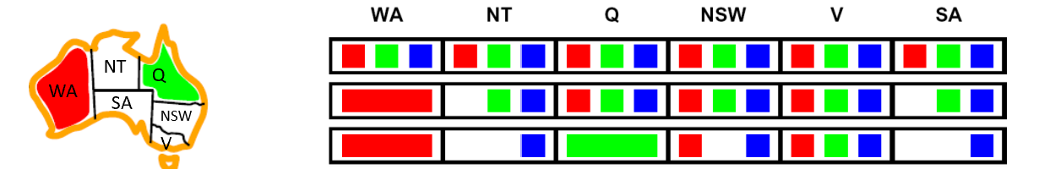

* NT and SA cannot both be blue!
* ***Constraint propagation***repeatedly enforces constrains locally*.*

Consistency-Enforcing Procedure 2: Constraint Propagation

* Using the constraints to reduce the number of legal values for a variable
* **Constraint propagation** may be intertwined with search, or it may be done as a preprocessing step, before search starts
* Sometimes this preprocessing can solve the whole problem, so no search is required at all!
* **Local consistency**

Arc Consistency

* An arc X → Y **is consistent**iff for *every* x in the tail there is *some* y in the head which could be assigned **without violating a constraint**

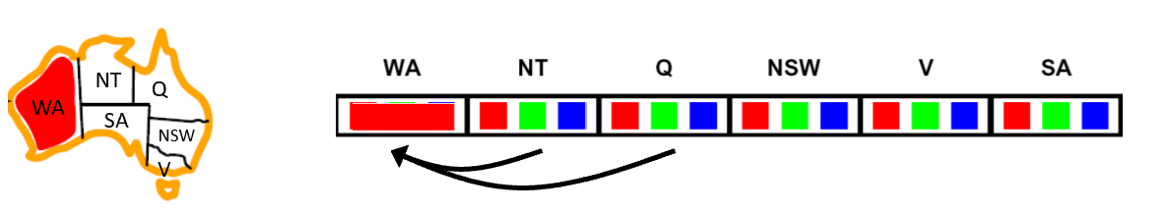

* **Forward checking**: Enforcing consistency of arcs pointing to each new assignment

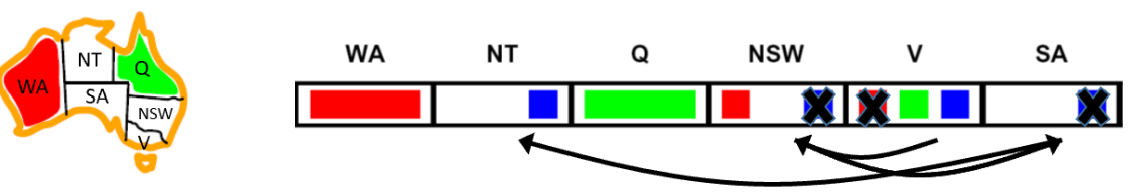

. Arc consistency detects failure earlier than forward checking

. Can be run as a **preprocessor** or after each assignment

Arc Consistency

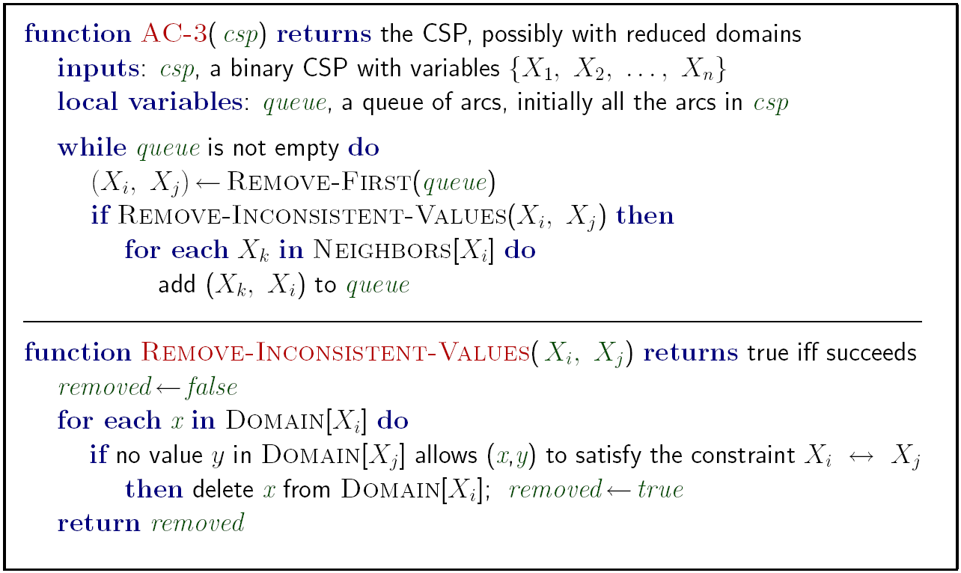

Runtime: O(n2d3) n: # of variables d: domain size

Limitations of Arc Consistency

* After enforcing arc consistency:
  + Can have **one** solution left
  + Can have **multiple** solutions left
  + Can have **no** solutions left (and not know it)

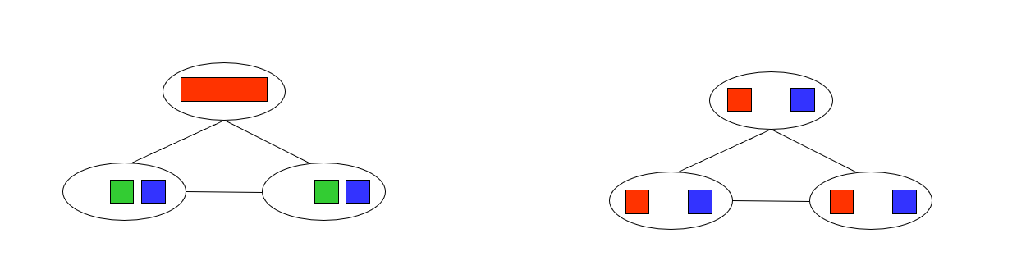

K-Consistency

* 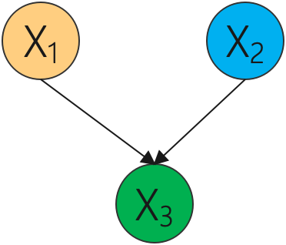Increasing **degrees** of consistency
  + **1-Consistency** (Node Consistency): Each single node’s domain has a value which meets that node’s **unary constraints**
  + **2-Consistency** (Arc Consistency): For each pair of nodes, any consistent assignment to one can be extended to the other
  + **K-Consistency**: For each k nodes, any consistent assignment to k-1 can be extended to the kth node.

Consistency-Enforcing Procedures

* **Forward checking**
* **Constraint propagation**
* **Variable/value ordering heuristics**
* They can used in combination to improve search process.

General Purpose CSP Algorithm

1. If all values have been successfully assigned then stop, else go on to 2.
2. Apply the **consistency enforcing procedure** (e.g. **forward checking** if feeling computationally mean, or **constraint propagation** if extravagant.)
3. If a deadend is detected then backtrack (e.g., DFS-type backtrack.). Else go on to step 4.
4. Select the next variable to be assigned (using your **variable ordering heuristic**)
5. Select a promising value (using your **value ordering heuristic**)
6. Create a new search state. Cache the info you need for backtracking. And go back to 1.

Local Search for CSPs

* **Hill-climbing, simulated annealing** typically work with “complete” states, i.e., all variables assigned
* To apply to CSPs:

allow states with unsatisfied constraints operators **reassign** variable values

* **Variable selection**: randomly select any conflicted variable
* **Value selection** by **min-conflicts** heuristic:

Choose value that violates the fewest constraints

i.e., hill-climb with h(n) = total number of violated constraints

Example: 4-Queens

* **States**: 4 queens in 4 columns (256 states)
* **Actions**: move queen in column
* **Goal test**: no attacks
* **Evaluation**: h(n) = number of attacks

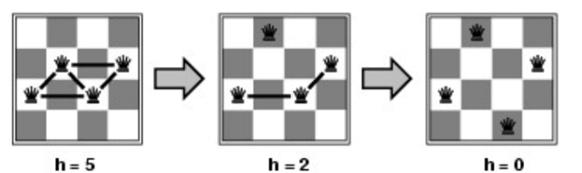

* Give random initial state, can solve n-queens in almost constant time for arbitrary n with high probability (e.g., n = 10,000,000)